How to perform an email Account Setup in Microsoft Outlook 2013-2016 (SSL Settings)
Open Outlook 2016
Select File > Add Account
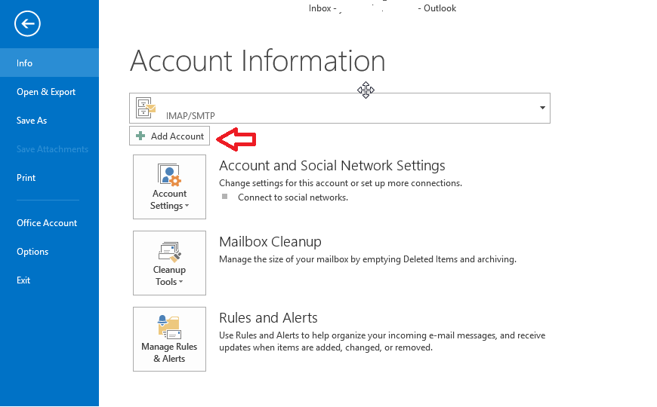
You will see a box as shown below. And you may proceed to fill in your name, email address and password. Click Next.
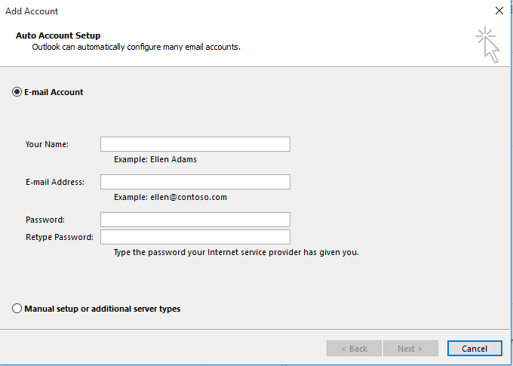

After some time, your email will be configured. If not and a box appears like below:
Just click Next to set up unencrypted connection.
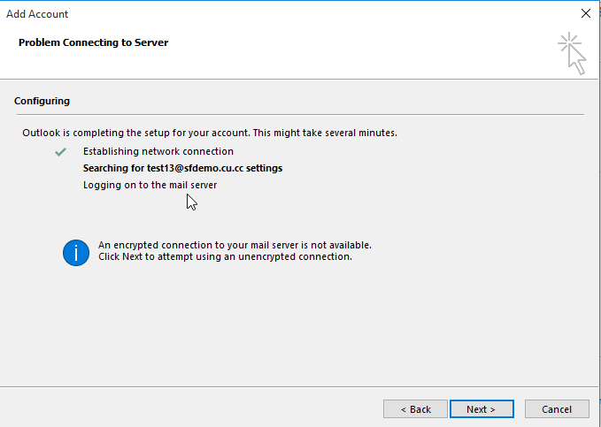
Click Finish and you have successfully configured your email account .
Note that you are using IMAP.
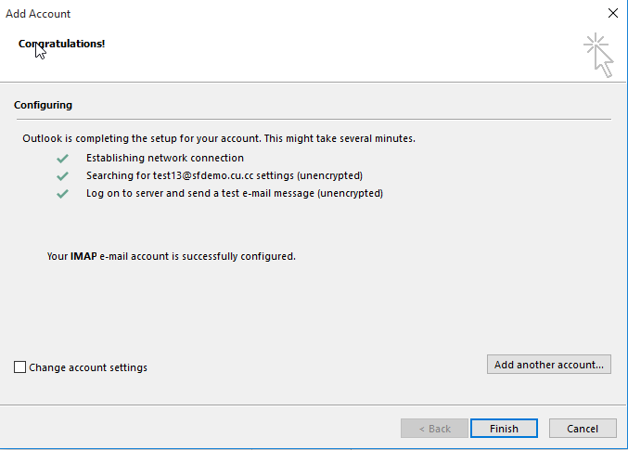
However, if even unencrypted email fails, you can try to manually configure your email settings.
Manually Configuring Email Settings
Click on Manual set up or additional server types and click Next.
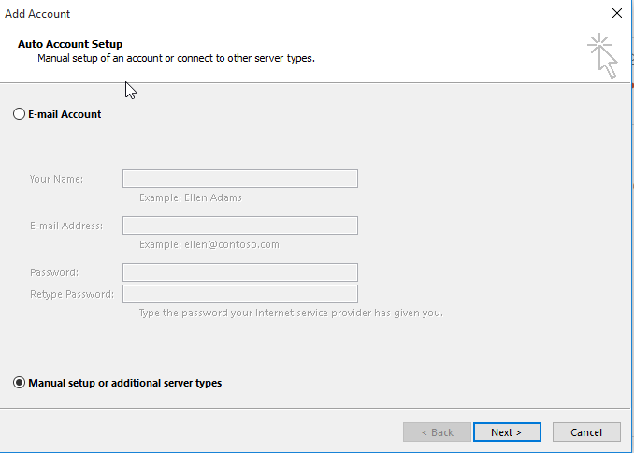
Click on POP or IMAP and click Next.
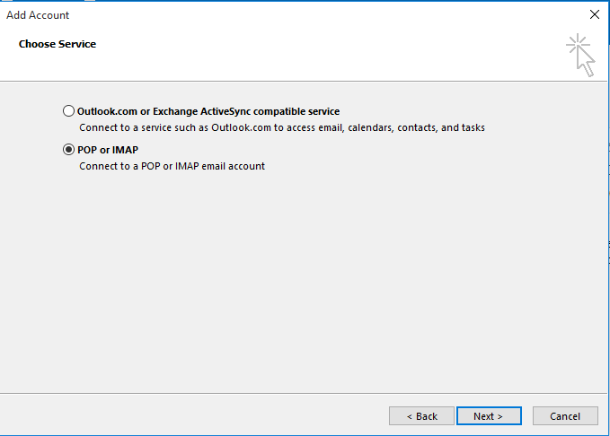

Fill in all the spaces below. Next, click on More Settings.
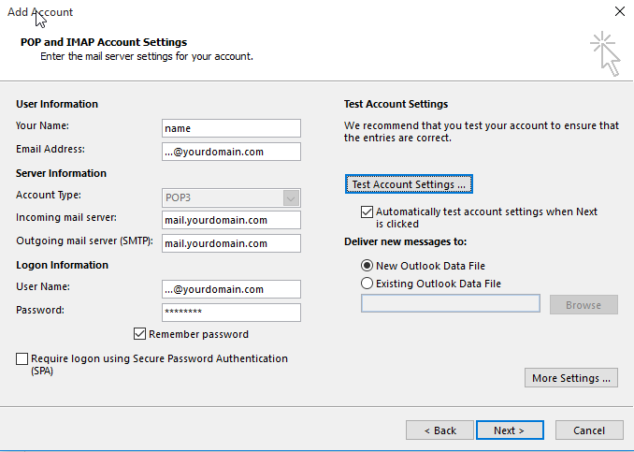
On the INCOMING MAIL SERVER settings page,
Username: user@yourdomain.com where it should be your email address.
Password: your email account password
IMAP/POP3 server : mail.prubsnadvisor.com.my
On the OUTGOING MAIL SERVER settings page,
Username: user@yourdomain.com where it should be your email address.
Password : your email account password
SMTP server : mail.prubsnadvisor.com.my
Go to Outgoing Server and tick “My outgoing server SMTP requires authentication" then click the radio button next to Use same settings as my incoming mail server.
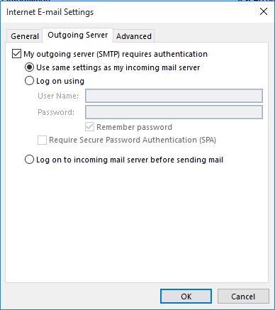

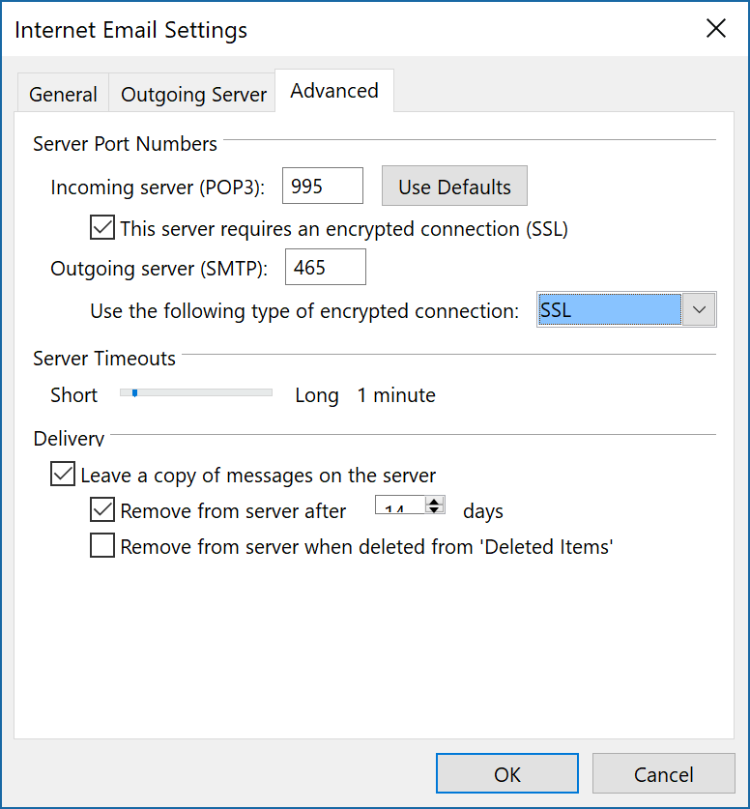
Go to Advanced and change the Incoming Server Port (IMAP) to 993.
If you're using POP3 settings, set the Incoming Server Port (POP3) to 995 as seen below.
Select ‘encrypted connection’ (SSL).
Security type: SSL/TLS (accept all certificates)
Incoming Server Port: 993 (IMAP) / 995 (POP3)
Security type: SSL/TLS (accept all certificates)
Outgoing Server Port: 465
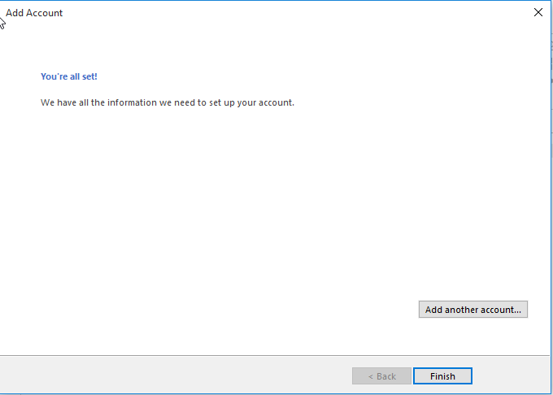
Click Next, then press the Finish button.

