How to Setup Email Account in iPhone (iOS 11)
The steps below can be applied only to the following models:
iPhone X
iPhone 8 / 8 Plus
iPhone 7 / 7 Plus
iPhone SE
iPhone 6 / 6 Plus / 6s / 6s Plus
iPhone 5s
Tap Settings from the home screen of your iPhone
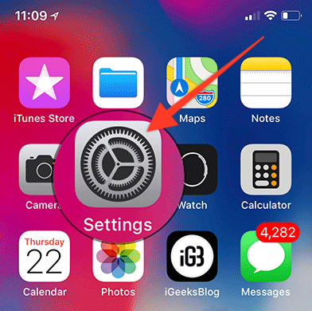
Tap Accounts & Passwords.
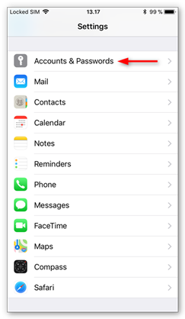
Choose Add Account
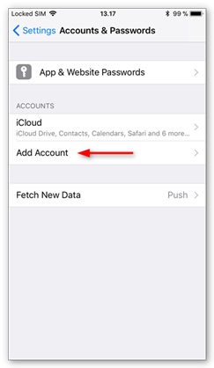
A list of email providers will appear. Choose Other
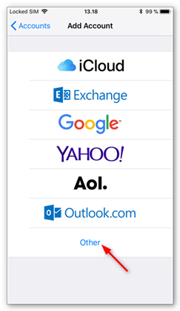
Choose Add Mail Account
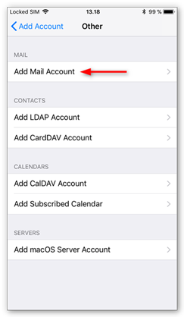
Enter the following details:
Name: Enter the sender name you’d like to appear on your emails.
Email: Your full email address.
Password: Your email account password.
Description: A description to identify the account.
Tap Next to continue...
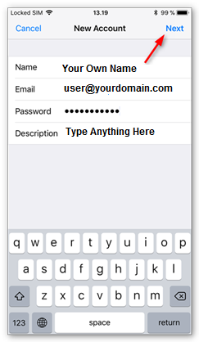
You can now choose to configure an IMAP or POP account by tapping the respective tab. Your selection will be highlighted in blue.
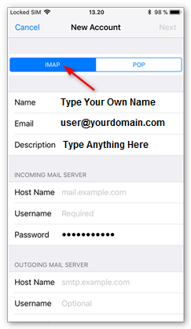
For Incoming Mail Server configuration, enter the following details:
Host Name: For POP or IMAP accounts, use mail.prubsnadvisor.com.my
User Name: Your email account user name.
Password: Your email account password.
Note: yourdomain.com shall be replaced with your own domain name.
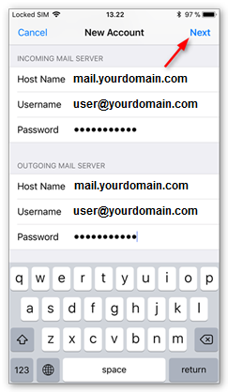
For Outgoing Mail Server configuration, enter the following details:
Host Name: For POP or IMAP accounts, use mail.prubsnadvisor.com.my
User Name: Your email account user name.
Password: Your email account password.
Note: yourdomain.com shall be replaced with your own domain name.
Tap the Next button and then click on the Save button.
You will be redirected to the Accounts & Passwords screen. Tap your newly created account to continue, then tap your email address in the screen that follows.

In the Account details screen, scroll down and tap Advanced.
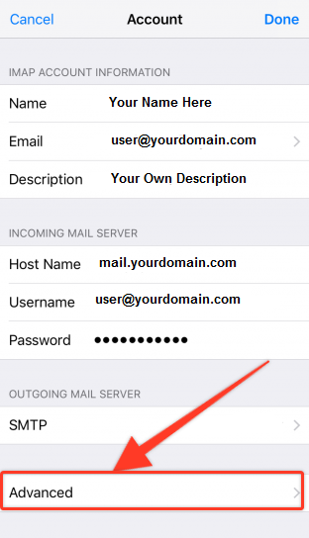
Enter the following details:
Incoming Mail Server settings:
a) For IMAP accounts, ensure Server Port is set to 993
b) For POP accounts, ensure Server Port is set to 995

Ensure Use SSL is selected.
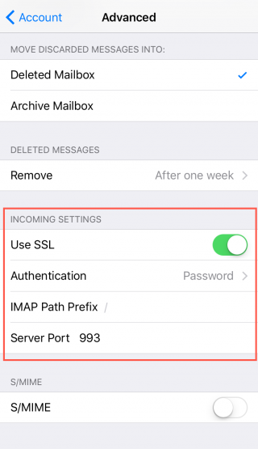
Return to the previous menu by tapping the Account button at the top of the screen. Scroll down to Outgoing Mail Server and tap the SMTP entry with the host name of the server. Tap the host name again, which will be listed under Primary Server.
Enter the following details:
Outgoing Mail server Settings: Ensure the server port is set to 465 for both IMAP and POP accounts. Ensure Use SSL is selected.
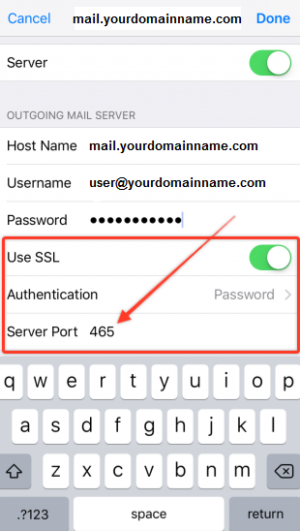
Tap Done at the top right corner of your screen. The server details will now be checked and your email account should be available for use.

