How to Setup an Email Account in Android Smartphone
Click into your Email application on the phone, or Mail.
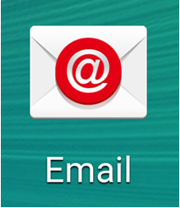
Enter your email address, password and click Next.
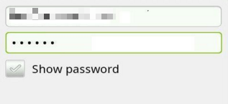
Select POP or IMAP based on the email account that you have.
On the Incoming server settings page,
Username: user@yourdomain.com where it should be your email address.
Password : your email account password
IMAP/POP3 server : mail.prubsnadvisor.com.my
Security type : SSL/TLS (accept all certificates)
Server Port : 993 (IMAP) / 995 (POP3)
Click the Next button

On the Outgoing server settings page,
Username: user@yourdomain.com where it should be your email address.
Password : your email account password
SMTP server : mail.prubsnadvisor.com.my
Security type : SSL/TLS (accept all certificates)
Server Port : 465
Then select Next.
For account options, you may choose your preferable settings or leave it as default. Click Next
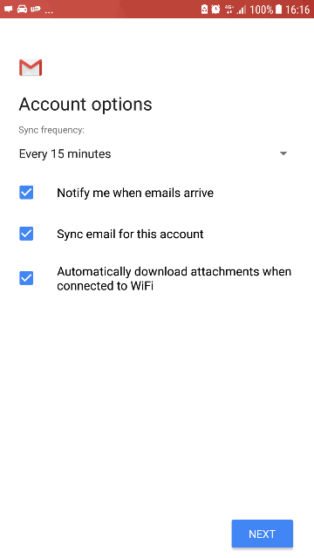
The last step will be enter Your name, which will be displaying in your email that you send, after that click "Next" to complete the setup.

